OSLAND GLOBAL NETWORKS LIMITED
REGISTERED COMPANY NAME: Osland Global Networks Ltd
COMPANY LOGO


COMPANY PROFILE/ABOUT US
Osland Global Networks Limited is a company established on the principles of integrity, discipline, accountability and value for money. The company specialises in the production and timely supply of varieties of products and services which include but not limited to production and supply of cow horn and hooves products, import and exports of goods, export of agricultural products, animal husbandry services, aquarium services, crops and animal production, piggery and/fish/poultry farming products, livestock feed production and distribution, sales of agricultural produce, delivery services, etc.
The company is committed to providing products and services that meet international standard and its international customers’ needs at the shortest possible time and at the highest level of quality.
MISSION AND VISSION
The mission of Osland Global Networks ltd is to meet the unending needs of its customers worldwide with precision and high level efficiency.
VISSION
Our vision is to be a first class reliable and powerful supplier of products and services to our customers all over the world.

COMPANY HISTORY/ BACKGROUND
OGN is a company founded in 2026 to be a solution to emerging needs of people within and outside the country Nigeria. The objectives are to consistently search for ways to make use of local materials to produce products that are of international standards. The company produces cow horn products like block tips, round tips, executive tea and wine cups, handles of all sorts, buttons, polished horns, tips, etc. the company is determined to meet the orders from our potential clients worldwide without undue delay.
OFFICE ADDRESS
OGN office is headquartered at NO 1, Ijadola Shopping Complex, Orire Junction, Opposite Winners Chapel, Ondo Road, Akure, Ondo State, Nigeria.
EMAIL:
oslandglobal@info4oslandglobal.com
PHONE NUMBERS
08037794385, 09038323542
WHATSAPP NO:
08037794385
SOCIAL MEDIA LINKS
………………………………
CAC/BUSINESS REGISTRATION DETAILS:
Business Registration No: 9303565
B. PRODUCTS INFORMATION
1. Cow horns: Cow horns are the horns of cows that have been processed into more refined forms for ornamental purposes or for further production process.
2. Cow Hide/Skin: This can exist in the unprocessed or in the processed form. The unprocessed is the braw form as it is removed from the body of cows and then dried. The processed forms are in form of leather for further production processes.
3. Cow Bones: These are bones from cows that are dried and grounded into usable powder form.
4. Cow Hooves: these are hooves removed from the feet of cows. These are used to produce crushed hooves which serve as raw materials for further production process.
5. Cow Bile Stone: This is found in some cows and its used as raw material for further production process.
6. Cow Horn buttons: These are buttons made from cow horn for fashion and other very important uses.
7. Cow Horn Cups: These are specialized and unique executive cups made from cow horns.
8. Knife Handle: These are produced from cow horns for domestic and surgical knife handles among other varieties of uses

9. Crafts from cow horns and other products are also available on demand.
10. Crushed Horn: These are crushed horn that are packed in bags in different quantities depending on the need of our customers. There is also cow horn powder in different quantities depending on the need our customers.
11. Crushed Hooves: These are hooves that have been crushed and processed into rough and semi powder forms. They are also packed in different quantities depending on orders.
12. Gallstone: This is an organic solid that usually grow in hollow parts of the cow e.g. gallbladder.
13. Cow Horn Powder: This is a processed cow horn that has been processed into powder.
14. Others: You can order for any part or other bye product that you so desire. We shall make is available within an agreed time period.
PRODUCTS GALLERY
15. Block Tips: These are rectangular shaped cow horn products with varying sizes ranging from 15mm to 25mm by 70mm.
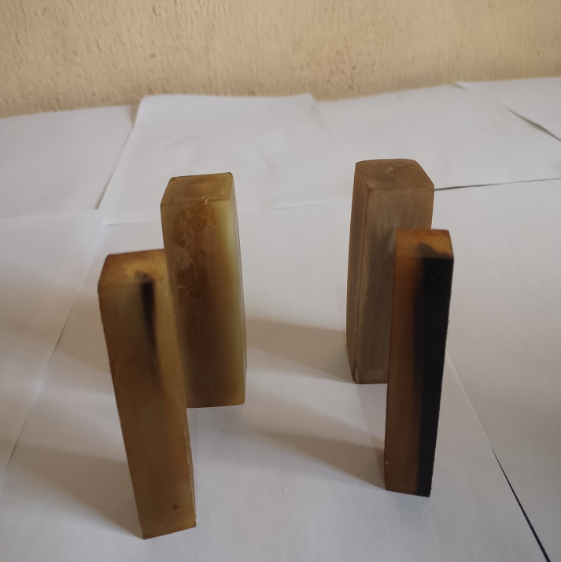
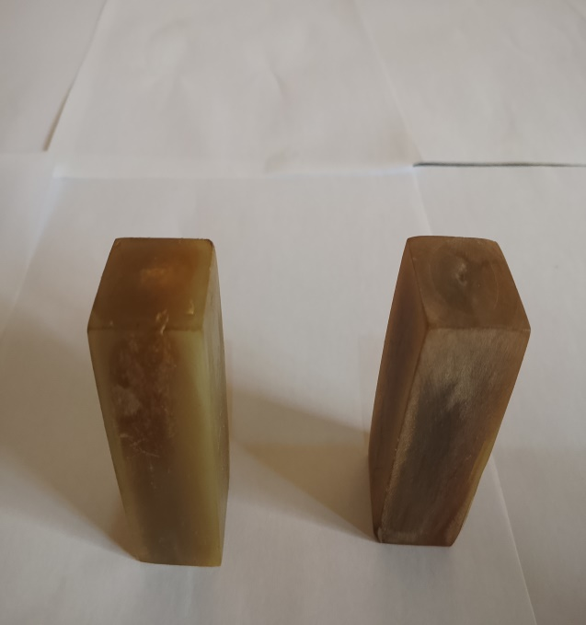

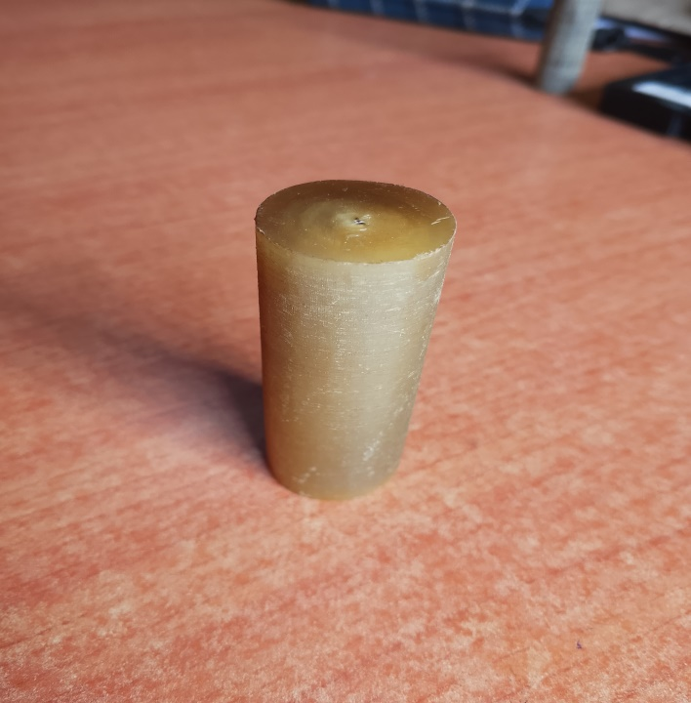
Round Tips: These are circular tips with diameter ranging from 15mm to 30mm by 70mm
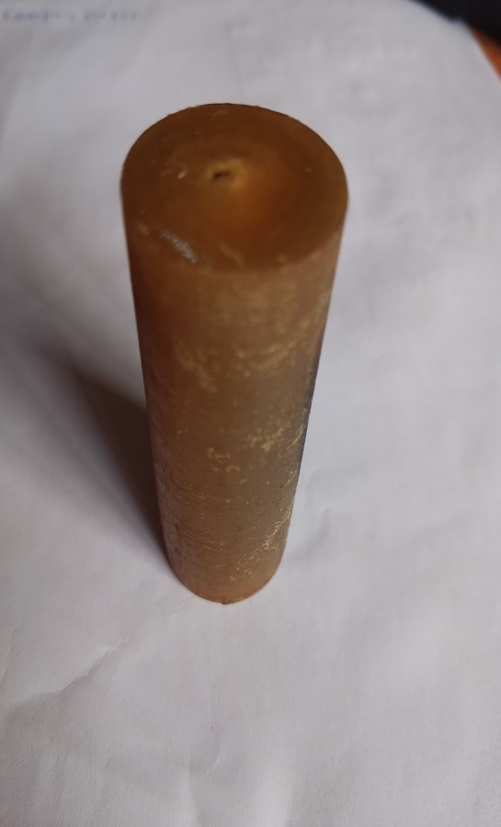
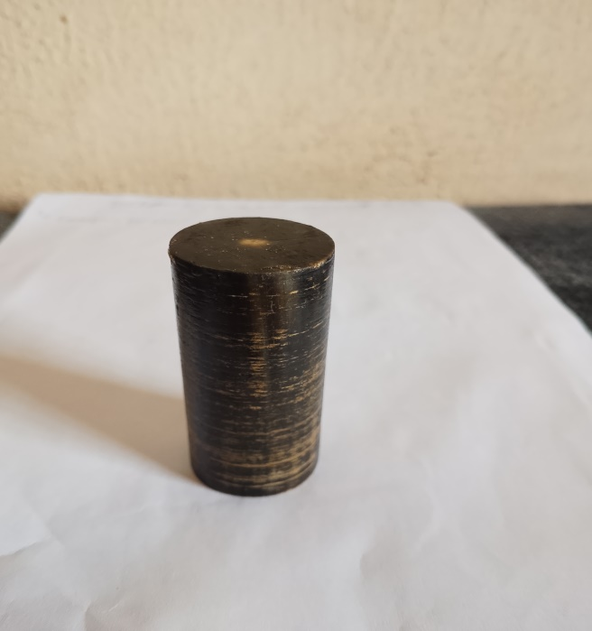
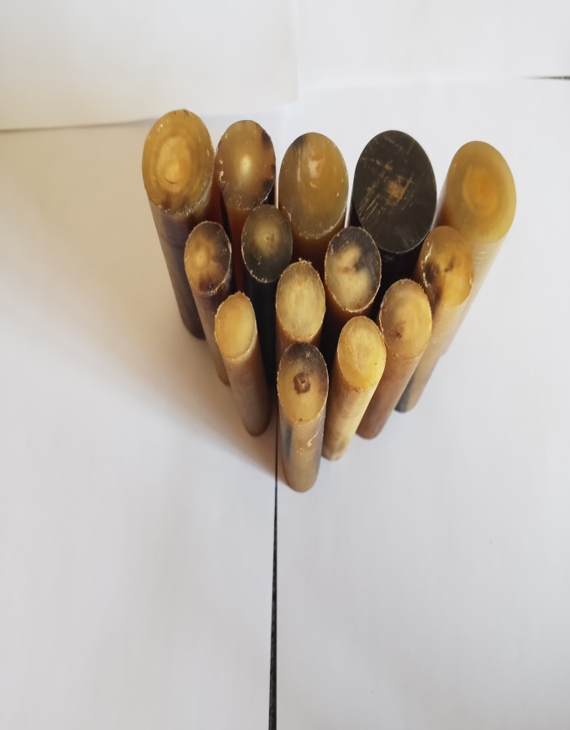

Knife handle these are flat handles made from cow horn with thickness varying from 4mm to 6mm, width of 30mm and length of 100mm.
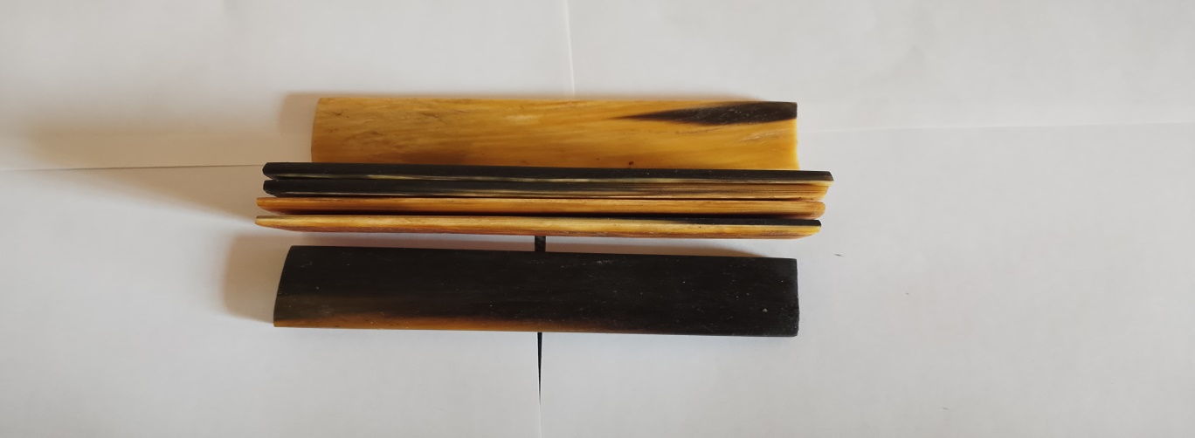
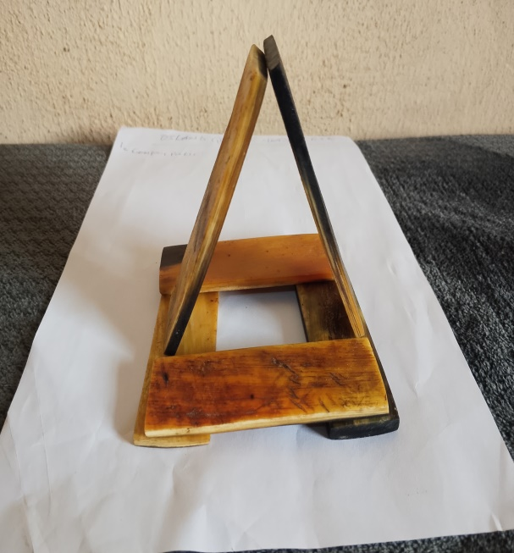
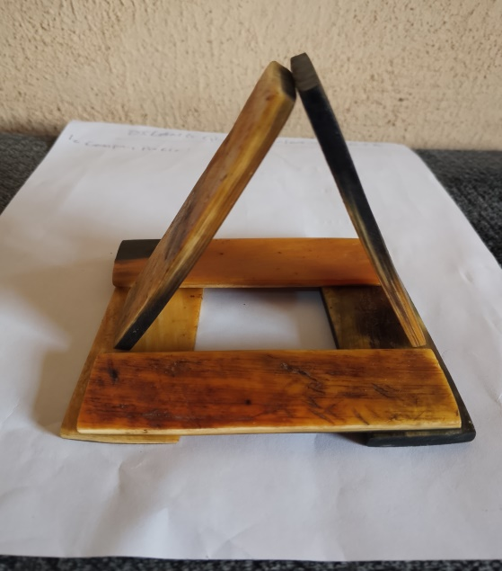
ttttttttttgggg

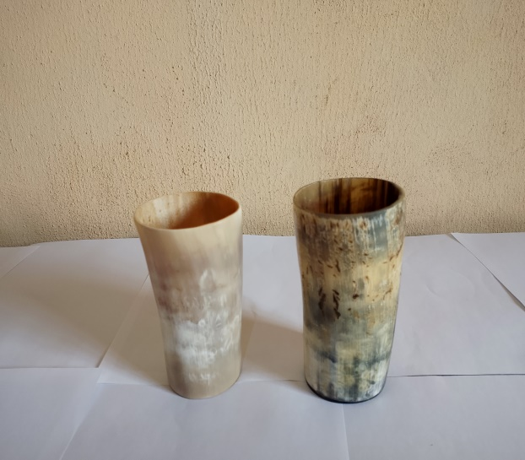
Cow horn cup: This is a cup made from cow horn. It could also be made into wine cup for executive use. These vary in sizes and designs.
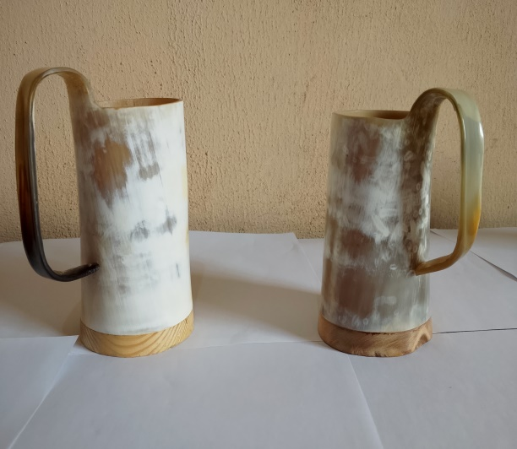
Polished Cow Horn: these are polished cow horns that have been processed into shining forms different from their natural forms
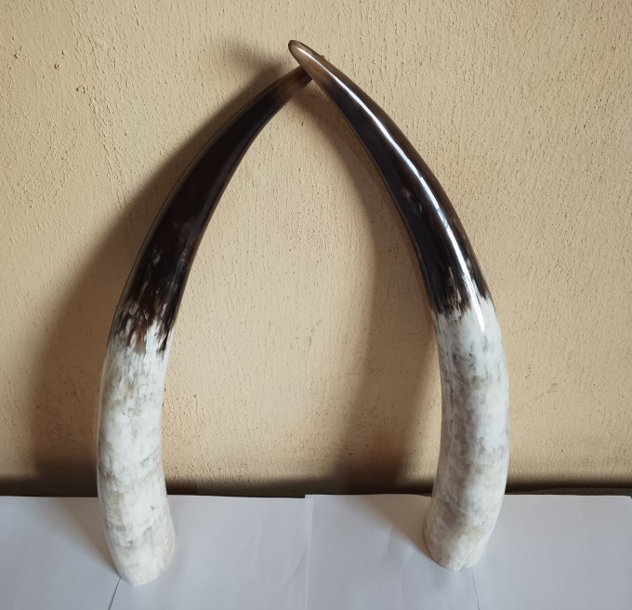
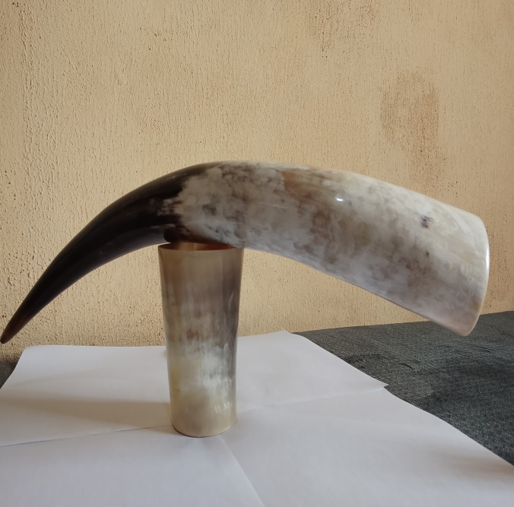

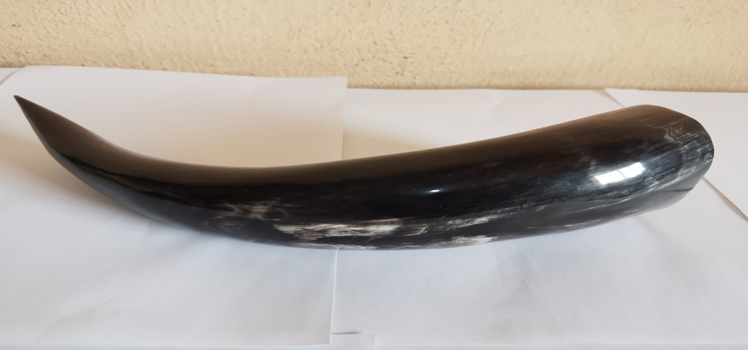

CONTACT DETAILS:
PHONE NO: 08037794385, 09038323542
EMAIL: oslandglobal@info4oslandglobal.com
EMAIL: esvsuccess100@gmail.com

